**Logical model for traffic flow management system:**

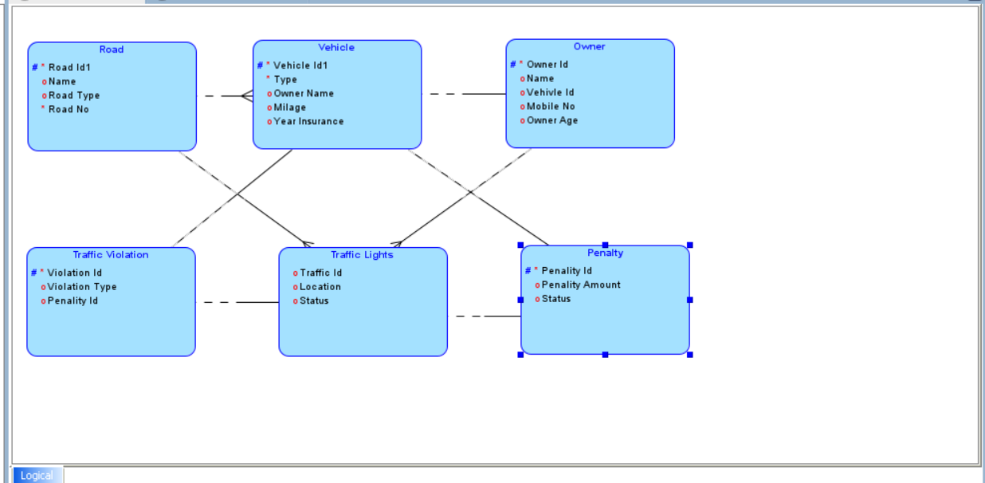

**Relational model for traffic flow management system:**

